**Assignment No.13**

**Roll No:-**

**Q. Write an ASP.NET Program to Perform Insert & Update Operation in Database Using Disconnected Architecture.**

**Design Code:-** *(WebForm1.aspx)*

<%@PageLanguage="C#"AutoEventWireup="true"CodeBehind="WebForm1.aspx.cs"Inherits="Disconnected_Architecture.WebForm1"%>

<!DOCTYPEhtml>

<htmlxmlns="http://www.w3.org/1999/xhtml">

<headrunat="server">

<title></title>

<styletype="text/css">

.auto-style1 {

width: 100%;

}

.auto-style2 {

width: 240px;

}

.auto-style3 {

width: 240px;

height: 31px;

}

.auto-style4 {

height: 31px;

}

</style>

</head>

<body>

<formid="form1"runat="server">

<div>

</div>

<tableclass="auto-style1">

<tr>

<tdclass="auto-style2">

<asp:LabelID="Label1"runat="server"Font-Bold="True"Font-Size="Large"Text="Roll No:"></asp:Label>

</td>

<td>

<asp:TextBoxID="TextBox1"runat="server"Font-Size="Large"></asp:TextBox>

</td>

</tr>

<tr>

<tdclass="auto-style2">

<asp:LabelID="Label2"runat="server"Font-Bold="True"Font-Size="Large"Text="Name:"></asp:Label>

</td>

<td>

<asp:TextBoxID="TextBox2"runat="server"Font-Size="Large"></asp:TextBox>

</td>

</tr>

<tr>

<tdclass="auto-style3">

<asp:LabelID="Label3"runat="server"Font-Bold="True"Font-Size="Large"Text="Class:"></asp:Label>

</td>

<tdclass="auto-style4">

<asp:TextBoxID="TextBox3"runat="server"Font-Size="Large"></asp:TextBox>

</td>

</tr>

<tr>

<tdclass="auto-style2">

<asp:LabelID="Label4"runat="server"Font-Bold="True"Font-Size="Large"Text="Mobile No:"></asp:Label>

</td>

<td>

<asp:TextBoxID="TextBox4"runat="server"Font-Size="Large"></asp:TextBox>

</td>

</tr>

<tr>

<tdclass="auto-style2">

<asp:LabelID="Label5"runat="server"Font-Bold="True"Font-Size="Large"Text="EmailId:"></asp:Label>

</td>

<td>

<asp:TextBoxID="TextBox5"runat="server"Font-Size="Large"></asp:TextBox>

<br/>

</td>

</tr>

</table>

<asp:ButtonID="btninsert"runat="server"Font-Bold="True"Font-Size="Large"Text="Insert"OnClick="btninsert_Click"/>

&nbsp;&nbsp;&nbsp;&nbsp;

&nbsp;

<asp:ButtonID="btndelete0"runat="server"Font-Bold="True"Font-Size="Large"Text="View"OnClick="btndelete0_Click"/>

&nbsp;&nbsp;&nbsp;&nbsp;&nbsp;&nbsp;&nbsp;

<asp:ButtonID="btnupdate"runat="server"Font-Bold="True"Font-Size="Large"Text="Update"OnClick="btnupdate_Click"/>

&nbsp;&nbsp;&nbsp;&nbsp;

&nbsp;

<asp:ButtonID="btndelete"runat="server"Font-Bold="True"Font-Size="Large"Text="Delete"OnClick="btndelete_Click"/>

<br/>

&nbsp;

<br/>

&nbsp;&nbsp;&nbsp;&nbsp;&nbsp;&nbsp;&nbsp;&nbsp;&nbsp;&nbsp;&nbsp;&nbsp;&nbsp;&nbsp;&nbsp;&nbsp;&nbsp;&nbsp;&nbsp;&nbsp;&nbsp;&nbsp;&nbsp;&nbsp;&nbsp;&nbsp;&nbsp;&nbsp;&nbsp;&nbsp;

<asp:LabelID="Label6"runat="server"Font-Size="Large"Font-Bold="True"></asp:Label>

<br/>

<asp:SqlDataSourceID="SqlDataSource1"runat="server"></asp:SqlDataSource>

<asp:GridViewID="GridView1"runat="server"CellPadding="4"ForeColor="#333333"GridLines="None"Width="643px">

<AlternatingRowStyleBackColor="White"ForeColor="#284775"/>

<EditRowStyleBackColor="#999999"/>

<FooterStyleBackColor="#5D7B9D"Font-Bold="True"ForeColor="White"/>

<HeaderStyleBackColor="#5D7B9D"Font-Bold="True"ForeColor="White"/>

<PagerStyleBackColor="#284775"ForeColor="White"HorizontalAlign="Center"/>

<RowStyleBackColor="#F7F6F3"ForeColor="#333333"/>

<SelectedRowStyleBackColor="#E2DED6"Font-Bold="True"ForeColor="#333333"/>

<SortedAscendingCellStyleBackColor="#E9E7E2"/>

<SortedAscendingHeaderStyleBackColor="#506C8C"/>

<SortedDescendingCellStyleBackColor="#FFFDF8"/>

<SortedDescendingHeaderStyleBackColor="#6F8DAE"/>

</asp:GridView>

</form>

</body>

</html>

**Code:- (***WebForm1.aspx.cs***)**

using System;

usingSystem.Collections.Generic;

usingSystem.Linq;

usingSystem.Web;

usingSystem.Web.UI;

usingSystem.Web.UI.WebControls;

usingSystem.Data;

usingSystem.Data.SqlClient;

namespaceDisconnected_Architecture

{

publicpartialclass WebForm1 : System.Web.UI.Page

{

SqlConnection con = newSqlConnection(@"Data Source=(LocalDB)\v11.0;AttachDbFilename=C:\BSc.CS3\Disconnected_Architecture\Disconnected_Architecture\App_Data\Database1.mdf;Integrated Security=True");

publicDataTabledt;

SqlDataAdapter da;

protectedvoidPage_Load(object sender, EventArgs e)

{

da=newSqlDataAdapter("select * from Student",con);

DataSet ds=newDataSet();

da.Fill(ds);

GridView1.DataSource=ds.Tables[0];

GridView1.DataBind();

}

protectedvoidbtninsert_Click(object sender, EventArgs e)

{

con.Open();

da = newSqlDataAdapter("select * from Student", con);

da.InsertCommand = newSqlCommand("insert into Student values(@p1,@p2,@p3,@p4,@p5)", con);

SqlCommandcmd = da.InsertCommand;

cmd.Parameters.AddWithValue("@p1", TextBox1.Text);

cmd.Parameters.AddWithValue("@p2", TextBox2.Text);

cmd.Parameters.AddWithValue("@p3", TextBox3.Text);

cmd.Parameters.AddWithValue("@p4", TextBox4.Text);

cmd.Parameters.AddWithValue("@p5", TextBox5.Text);

Label6.Text = "Student Details Has Inserted..!!";

cmd.ExecuteNonQuery();

Label6.Text = "Student Details Has Inserted..!!";

DataSet ds = newDataSet();

da.Fill(ds);

GridView1.DataSource = ds.Tables[0];

GridView1.DataBind();

}

protectedvoidbtndelete_Click(object sender, EventArgs e)

{

da.DeleteCommand = newSqlCommand("delete from Student where RollNO='" + TextBox1.Text + "'", con);

SqlCommandcmd = da.DeleteCommand;

con.Open();

cmd.ExecuteNonQuery();

try

{

int result = cmd.ExecuteNonQuery();

if (result >= 0)

{

Label6.Text = "Student Details Has Deleted..!!";

}

else

{

Label6.Text = "Failed To Delete Student Details..!!";

}

}

catch (SqlException ex)

{

Label6.Text = ex.Message;

}

finally

{

con.Close();

}

DataSet ds = newDataSet();

da.Fill(ds);

GridView1.DataSource = ds.Tables[0];

GridView1.DataBind();

con.Close();

}

protectedvoidbtnupdate_Click(object sender, EventArgs e)

{

string s = ("Update Student set RollNO='" + TextBox1.Text + "',Name='" + TextBox2.Text + "',Class='" + TextBox3.Text + "',MobileNo ='" + TextBox4.Text + "',EmailId ='" + TextBox5.Text + "' where RollNO='" + TextBox1.Text + "' ");

da.UpdateCommand = newSqlCommand(s, con);

SqlCommandcmd = da.UpdateCommand;

con.Open();

cmd.ExecuteNonQuery();

try

{

int result = cmd.ExecuteNonQuery();

if (result > 0)

{

Label6.Text = "Record Updated Successfully...!!";

}

else

{

Label6.Text = "Failed To Update Student Details..!!";

}

}

catch (SqlException ex)

{

Label6.Text = ex.Message;

}

finally

{

con.Close();

}

DataSet ds = newDataSet();

da.Fill(ds);

GridView1.DataSource = ds.Tables[0];

GridView1.DataBind();

con.Close();

}

protectedvoid btndelete0_Click(object sender, EventArgs e)

{

con.Open();

SqlCommandcmd = con.CreateCommand();

cmd.CommandType = CommandType.Text;

cmd.CommandText = "SELECT RollNo,Name,Class,MobileNo,EmailId FROM Student WHERE RollNO = '" + TextBox1.Text + "'";

{

cmd.CommandType = CommandType.Text;

cmd.Connection = con;

using (SqlDataReadersdr = cmd.ExecuteReader())

{

sdr.Read();

TextBox1.Text = sdr["RollNo"].ToString();

TextBox2.Text = sdr["Name"].ToString();

TextBox3.Text = sdr["Class"].ToString();

TextBox4.Text = sdr["MobileNo"].ToString();

TextBox5.Text = sdr["EmailId"].ToString();

}

}

}

}

}

**\*\*\*\*\*\*\*\*\*\*\*\*\*\*\*\*\*\*\*\*\*\*OUTPUT\*\*\*\*\*\*\*\*\*\*\*\*\*\*\*\*\*\*\***

**1)Inserting Student Details:-**

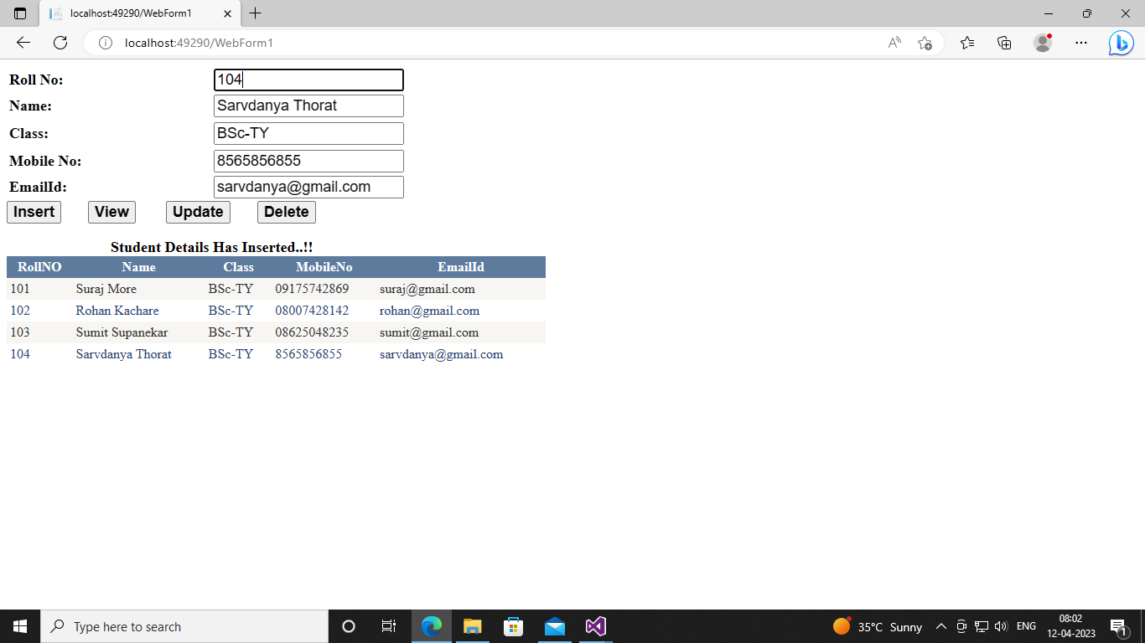

**2)Updating Student Details:-**

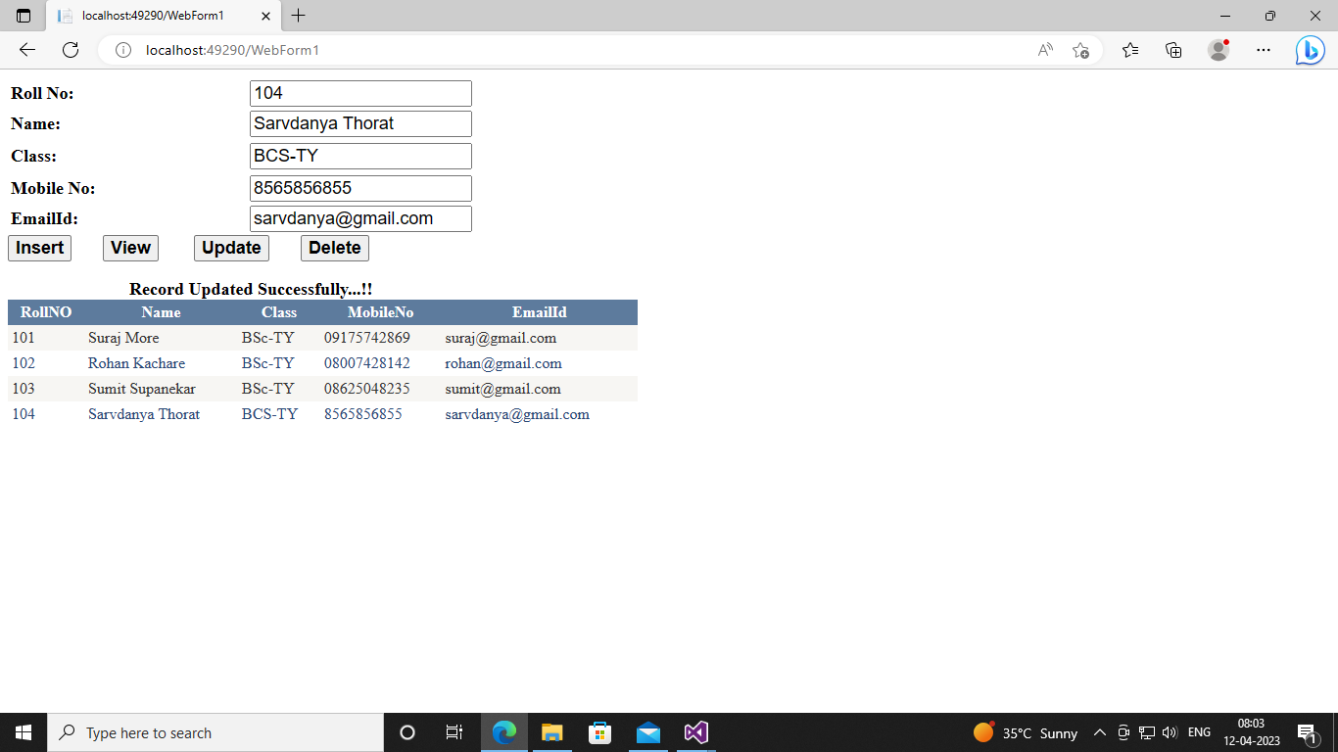

**3)Deleting Student Details:-**

